SANSKAAR PATNI
0S LAB7
CSE C 23
180905134

1. PRODUCER CONSUMER

#include <pthread.h>
#include <stdio.h>
#include <stdlib.h>
#include <unistd.h>
#include <semaphore.h>
int buf[10], f, r;
sem_t mutex, full, empty;
void *produce(void *arg)
{
int i;
for (i = 0; i < 20; i++)
{
sem_wait(&empty);
sem_wait(&mutex);
printf("produce item is %d\n", i);
buf[(++r) % 10] = i;
sleep(1);
sem_post(&mutex);
sem_post(&full);
}
}
void *consume(void *arg)
{
int item, i;
for (i = 0; i < 20; i++)
{
sem_wait(&full);
sem_wait(&mutex);
item = buf[(++f) % 10];
printf("consumed item is %d\n", item);
sleep(1);
sem_post(&mutex);
sem_post(&empty);
}
}
int main(int argc, char const *argv[])
{
pthread_t tid1, tid2;
sem_init(&mutex, 0, 1);
sem_init(&full, 0, 0);
sem_init(&empty, 0, 10);
pthread_create(&tid1, NULL, produce, NULL);
pthread_create(&tid2, NULL, consume, NULL);
pthread_join(tid1, NULL);
pthread_join(tid2, NULL);
return 0;
}

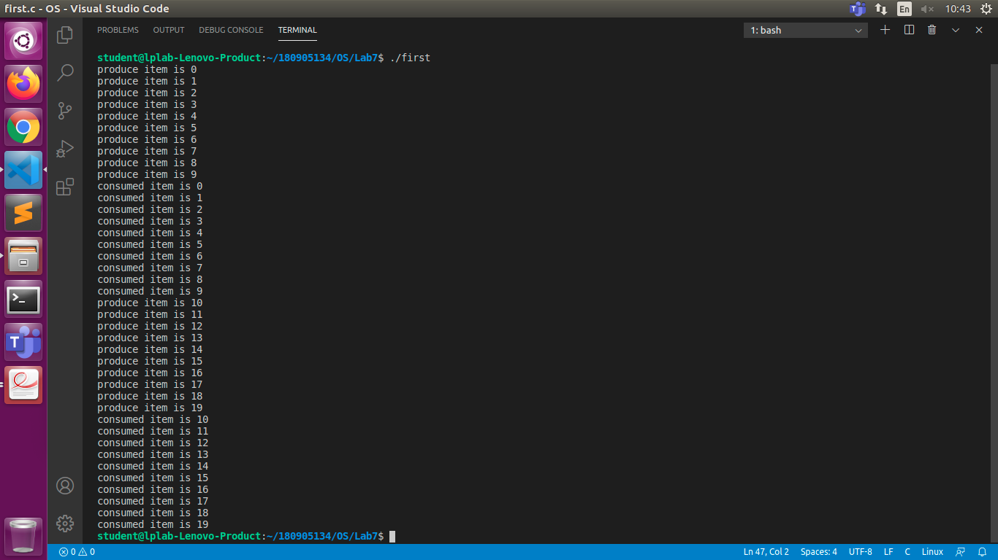

2.FIRST READERS WRITERS PROBLEM
#include <stdio.h>
#include <stdlib.h>
#include <pthread.h>
#include <semaphore.h>
sem_t mutex, writerbolock;
int readcount = 0, data = 0;

void *reader(void *arg)
{
int f = (int)arg;
sem_wait(&mutex);
readcount += 1;
if (readcount == 1)
sem_wait(&writerbolock);
sem_post(&mutex);
printf("Data read by user %d is %d \n", f, data);
sleep(1);
sem_wait(&mutex);
readcount -= 1;
if (readcount == 0)
{
sem_post(&writerbolock);
}
sem_post(&mutex);
}

void *writer(void *arg)
{
int f = (int)arg;
sem_wait(&writerbolock);
data++;
printf("Data written by writer %d is %d \n", f, data);
sem_post(&writerbolock);
}
int main()
{
int i, b;
pthread_t rtid[10], wtid[10];
sem_init(&mutex, 0, 1);
sem_init(&writerbolock, 0, 1);
printf("Input Data amount: ");
int n;
scanf("%d", &n);
for (i = 0; i < n; i++)
{
pthread_create(&wtid[i], NULL, writer, (void *)i);
pthread_create(&rtid[i], NULL, reader, (void *)i);
}
for (i = 0; i < n; i++)
{
pthread_join(wtid[i], NULL);
pthread_join(rtid[i], NULL);
}
printf("\n");
return 0;
}

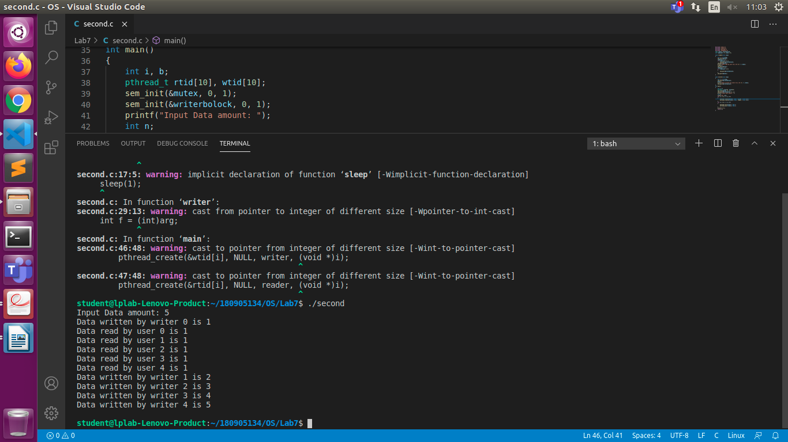
3. Improper use of semaphore

#include <stdio.h>
#include <unistd.h>
#include <pthread.h>
#include <sys/sem.h>
#define PERMS 0660

int semId;
int initSem(int semId, int semNum, int initValue)
{
return semctl(semId, semNum, SETVAL, initValue);
}

int P(int semId, int semNum)
{
struct sembuf operationList[1];
operationList[0].sem_num = semNum;
operationList[0].sem_op = -1;
operationList[0].sem_flg = 0;
return semop(semId, operationList, 1);
}

int V(int semId, int semNum)
{
struct sembuf operationList[1];
operationList[0].sem_num = semNum;
operationList[0].sem_op = 1;
operationList[0].sem_flg = 0;
return semop(semId, operationList, 1);
}

void *funcA(void *nothing)
{
printf("Thread A try to lock 0...\n");
P(semId, 0);
printf("Thread A locked 0.\n");
usleep(50 * 1000);
printf("Thread A try to lock 1...\n");
P(semId, 1);
printf("Thread A locked 1.\n");
V(semId, 0);
V(semId, 1);
return NULL;
}

void *funcB(void *nothing)
{
printf("Thread B try to lock 1...\n");
P(semId, 1);
printf("Thread B locked 1.\n");
usleep(5 * 1000);
printf("Thread B try to lock 0...\n");
P(semId, 0);
printf("Thread B locked 0.\n");
V(semId, 0);
V(semId, 1);
return NULL;
}

int main(int argc, char *argv[])
{
int i;
semId = semget(ftok(argv[0], 'A'), 2, IPC_CREAT | PERMS);
initSem(semId, 0, 1);
initSem(semId, 1, 1);
pthread_t thread[2];
pthread_create(&thread[0], NULL, funcA, NULL);
pthread_create(&thread[1], NULL, funcB, NULL);
for (i = 0; i < 2; i++)
{
pthread_join(thread[i], NULL);
}
printf("This is not printed in case of deadlock\n");
semctl(semId, 0, IPC_RMID, 0);
semctl(semId, 1, IPC_RMID, 0);
return 0;
}

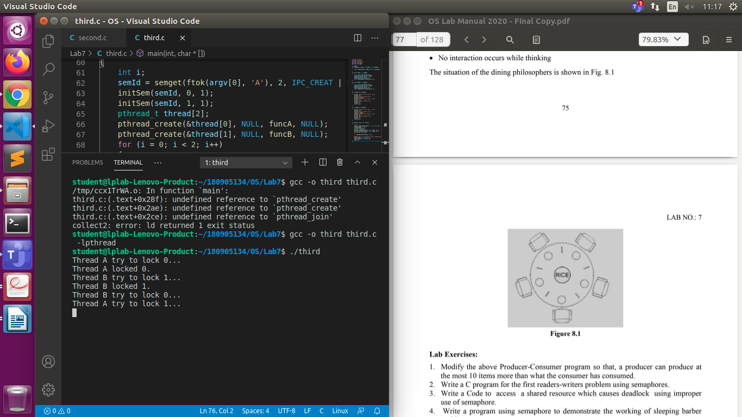
4. SLEEPING BARBER PROBLEM

#include <stdio.h>
#include <stdlib.h>
#include <unistd.h>
#include <pthread.h>
#include <errno.h>
#include <sys/ipc.h>
#include <semaphore.h>
#define N 5
time_t end_time; /*end time*/
sem_t mutex, customers, barbers; /*Three semaphors*/
int count = 0; /*The number of customers waiting for haircuts*/
void barber(void *arg);
void customer(void *arg);
int main(int argc, char *argv[])
{
pthread_t id1, id2;
int status = 0;
end_time = time(NULL) + 20; /*Barber Shop Hours is 20s*/
/*Semaphore initialization*/
sem_init(&mutex, 0, 1);
sem_init(&customers, 0, 0);
sem_init(&barbers, 0, 1);
/*Barber_thread initialization*/
status = pthread_create(&id1, NULL, (void *)barber, NULL);
if (status != 0)
perror("create barbers is failure!\n");
/*Customer_thread initialization*/
status = pthread_create(&id2, NULL, (void *)customer, NULL);
if (status != 0)
perror("create customers is failure!\n");
/*Customer_thread first blocked*/
pthread_join(id2, NULL);
pthread_join(id1, NULL);
exit(0);
}
void barber(void *arg) /*Barber Process*/
{
while (time(NULL) < end_time || count > 0)
{
sem_wait(&customers); /*P(customers)*/
sem_wait(&mutex); /*P(mutex)*/
count--;
printf("Barber:cut hair,count is:%d.\n", count);
sem_post(&mutex); /*V(mutex)*/
sem_post(&barbers); /*V(barbers)*/
sleep(3);
}
}
void customer(void *arg) /*Customers Process*/
{
while (time(NULL) < end_time)
{
sem_wait(&mutex); /*P(mutex)*/
if (count < N)
{
count++;
printf("Customer:add count,count is:%d\n", count);
sem_post(&mutex); /*V(mutex)*/
sem_post(&customers); /*V(customers)*/
sem_wait(&barbers); /*P(barbers)*/
}
else
/*V(mutex)*/
/*If the number is full of customers,just put the mutex lock let go*/
sem_post(&mutex);
sleep(1);
}
}

